Post Leaving Certificate Course (PLC) 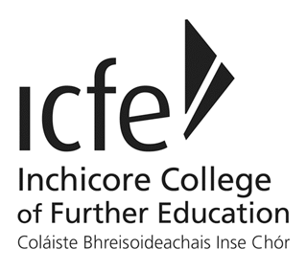

What is it?
- Usually 1 (level 5) or 2 (level 6) year courses
- Used as a stepping stone to University
- Fully recognised qualification in Ireland & abroad
- Courses offer practical learning as well as theory
- Opportunities for work experience and internships in Ireland & abroad
- Many qualify you to become self-employed
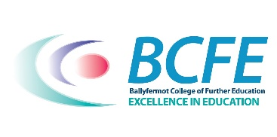
Benefits of PLC courses:
- Smaller classes
- More choice – media, drama, music, tourism, animation, design, hair & make up, etc.
- Lot’s of local colleges; ICFE, BCFE, Crumlin College, Liberties College, etc.
- Cheaper college fees
- SUSI maintenance grant available

How to apply? 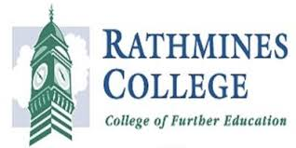
Application forms are available on each college website. You will need your pps number to apply. There is no fee to apply for plc courses. You should receive an email to conform your application. In this email, they may give you a username and password. You then use this to login on the college website to view any correspondence the college may send you. There is also an option to pay a deposit (usually €50) and fee here too.
At the moment, some colleges are not doing face to face interviews. Some are offering places based on your application and some are doing online interviews. You will be notified of this in your letter after you apply.

Progression Routes
When you have completed the PLC course, you can then apply through CAO for a Higher Education Course using the results from your PLC course rather than your Leaving Certificate. You can see the QQI links on qualifax or careersportal for each individual course.
It may be possible, in some plc colleges, to obtain a level 8 degree associated with a University in the plc college you are attending.
How to research courses
There is information available on careersportal.ie and qualifax.ie. You can also find information on each college website. We have had many of our students attend the following colleges:
- Ballyfermot College
- Inchicore College
- Crumlin College
- Rathmines College
- Liberties College
- Greenhills College
- Marino College
If you would like more information please contact the Guidance Counsellor, Ms Ni Chrualaoich by emailing her on sorchanichrualaoich@stkevinscc.ie or calling/texting 089 223 2005

